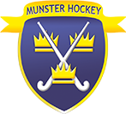

**PRO**

**CORE RESPONSIBILITIES:**

* Responsible for the promotion of hockey in Munster;
* Owner of all social media outlets;
* Creating content to actively promote the game of hockey;
* Manage the website;
* Seek sponsorship;
* Send weekly reports and fixtures to media outlets;
* Synopsys of position of Chair of MHUA.