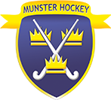

***Job Description Ordinary Member***

* Attend Management Committee Meeting
* Attend Interpro Interviews and debriefs in the event of key management being unavailable.
* Take gates at cup finals, help out when hosting Interpros & internationals in Munster
* Support in any area where possible within the running of Munster Hockey

|  |  |  |
| --- | --- | --- |
| |  | | --- | | https://mail.google.com/mail/u/0/images/cleardot.gif | |  |