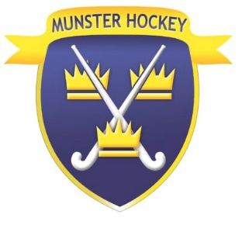

Code of Conduct for Parent/Guardian

Hockey wants to provide the best environment for all young people involved in the sport. Young people deserve to be given enjoyable, safe sporting opportunities free of abuse of any kind.

While the MBHI recognises that you as a parent/guardian are responsible for the primary care and welfare of your child within hockey, your child will be in the care of the sport leaders for the duration of events under the auspices of the MBHI and Hockey Ireland. To make the child’s hockey experience free of stress the sport leaders will need your support. You can help and support the implementation of best practise by following the Code below.

Hockey believes that parents / guardians should -

- Be a role model for your child and maintain the highest standards of conduct when interacting with young people, other parents, officials and organisers
- Never intentionally expose any young participant to embarrassment or disparagement by the use of flippant or sarcastic remarks
- Always recognise the value and importance of the officials and volunteers who provide sporting and recreational opportunities for your child. Do not publicly question their judgement or honesty. Respect Children’s Officers, Designated Persons, coaches, umpires, youth organisers, managers and other players
- Encourage your child to play by the rules. Teach your child that honest endeavour is as important as winning and do all you can to encourage good sportsmanship.
- Take an interest in your child’s sport and support the child’s participation in their chosen activity
- Support all efforts to remove abusive behaviour and bullying behaviour in all its forms.

