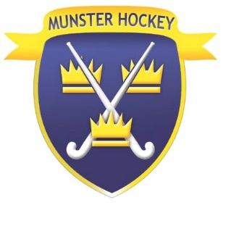

Club Code of Conduct for Internet and Social Media Use

The Munster Branch of Hockey Ireland (MBHI) understands the importance of online communication for children and young people’s development. However, we recognise that relevant safeguards need to be put in place to ensure children and young people remain safe while online or using social media.
All members of the MBHI using internet or social media must -
- be responsible for their behaviour when using the internet and social media at the sports club, including the content they access and how they conduct themselves.
- not deliberately create, browse, or access material that could be considered offensive or illegal. If they accidentally come across any such material, they should report this to a club committee member.
- not use social media or the internet to send anyone material that could be considered threatening, offensive, upsetting, bullying or that is illegal.

- understand that they should only use the club’s (or organisation’s) official social media or website communication channels to contact them and should not seek out individual club members, volunteers, or coaches.
- understand that all their use of internet and social media is potentially visible to everyone and that any issues involving their behaviour online may be addressed by their coach or other club committee members at the club.
- not give out any of their personal information (such as name, age, address, or telephone number online), or that of anyone else.
- not share their passwords with anyone else.
- not arrange to meet someone that they have met online unless accompanied by a member of staff or parent.

- understand that these rules are designed to keep them safe, and if they are not followed parents may be contacted.

- not post or share anything on social media you think may upset or offend someone.

